
SUBMITTED BY: HAZRAT UMAR
SUBMITTED TO: MR MUHAMMAD EJIZ
CLASS: BSSE 2023-C
SUBJECT: SOFTWARE CONSTRUCTION AND DEVELOPMENT
ROLL NO: 4309-C
SEMESTER: 5TH
SOFTWARE ENGINEERING
DATE: 24/11/2025
LAB TASK: 01

Code no 01:

Area of a circle:
import math
radius = float (input("Enter radius: "))
area = math.pi * radius ** 2
print("Area of circle: ",area )

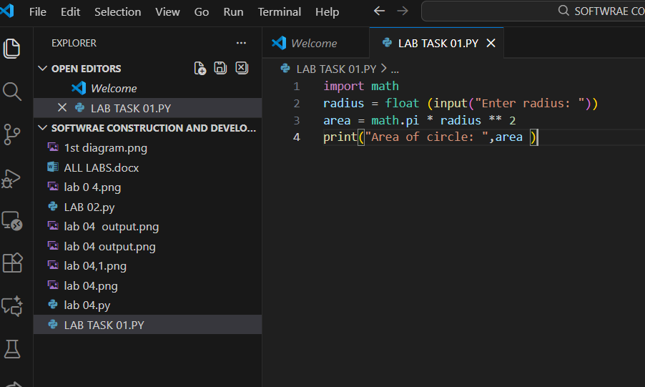

Output:
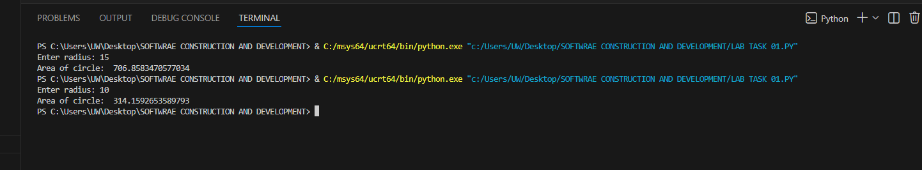

Code no 02:

Swap Two Numbers:
a = int (input("Enter first number: "))
b = int (input("Enter second number: "))
a, b = b, a
print("After swapping: a =", a, "b =", b)

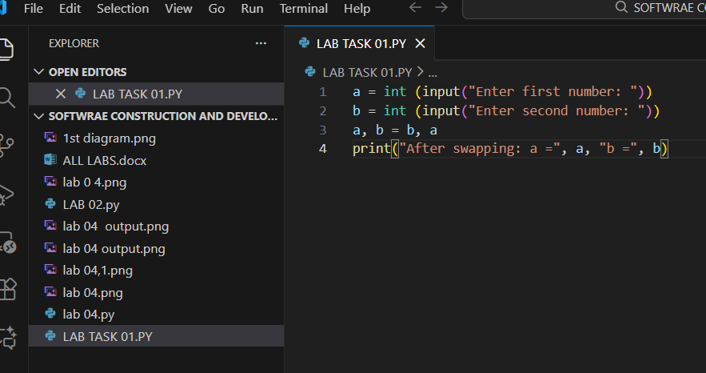

Output:
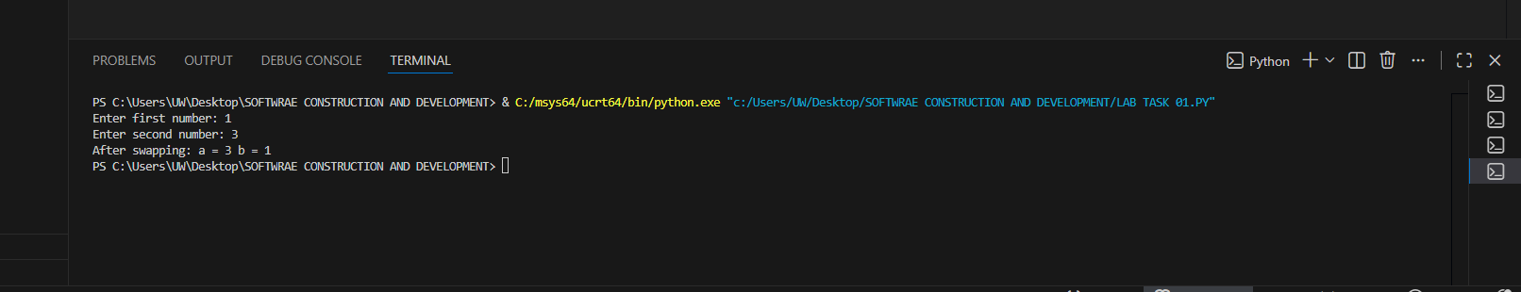

Code no: 03

Celsius to Fahrenheit:
c = float(input("Enter temperature in Celsius: "))
f = (c * 9/5) + 32
print("Fahrenheit:", f)

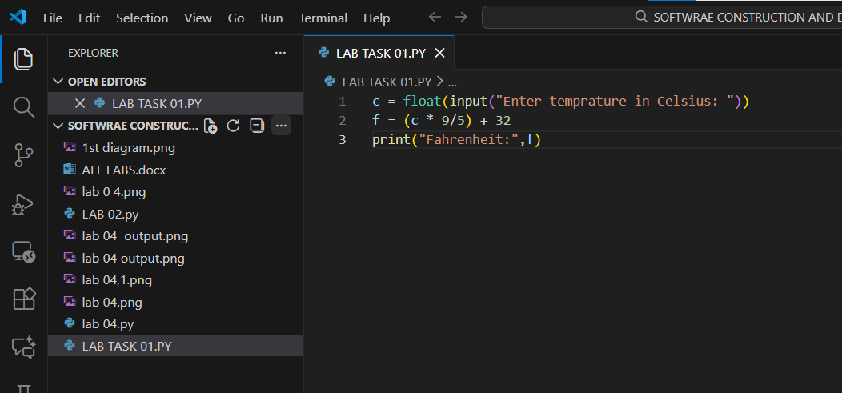

Output:
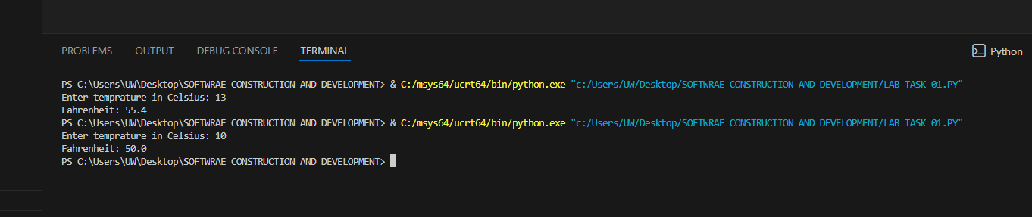

Code no: 04

Total Marks and Percentage:
marks = []
for i in range(5):
m = float(input(f"Enter marks for subject {i+1}: "))
marks.append(m)
total = sum(marks)
percentage = (total / 500) * 100
print("Total Marks:", total)
print("Percentage:", percentage)

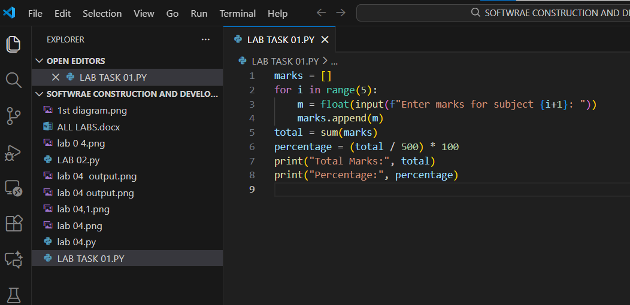

Output:
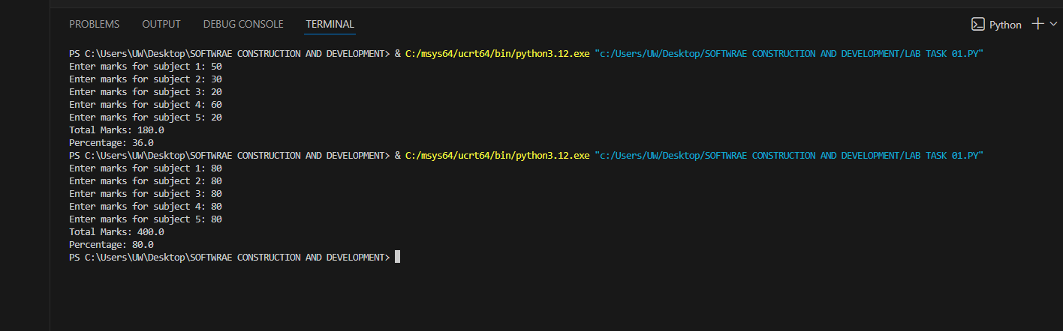

Code on: 05

Convert int to float and float to int:
x = int(input("Enter an integer: "))
y = float(input("Enter a float: "))
print("Integer to float:", float(x))
print("Float to integer:", int(y))

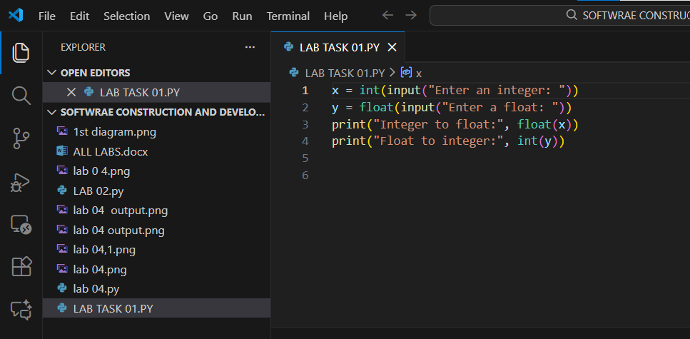

Output:
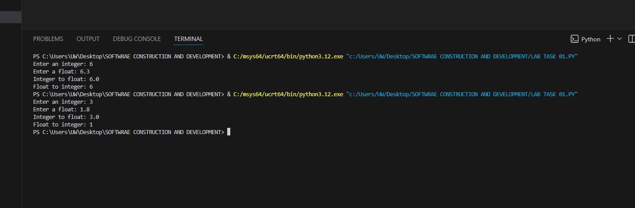

Code no:06

List: Sum, Max, Min:
nums = [10, 20, 5, 40, 15]
print("List:", nums)
print("Sum:", sum(nums))
print("Max:", max(nums))
print("Min:", min(nums))

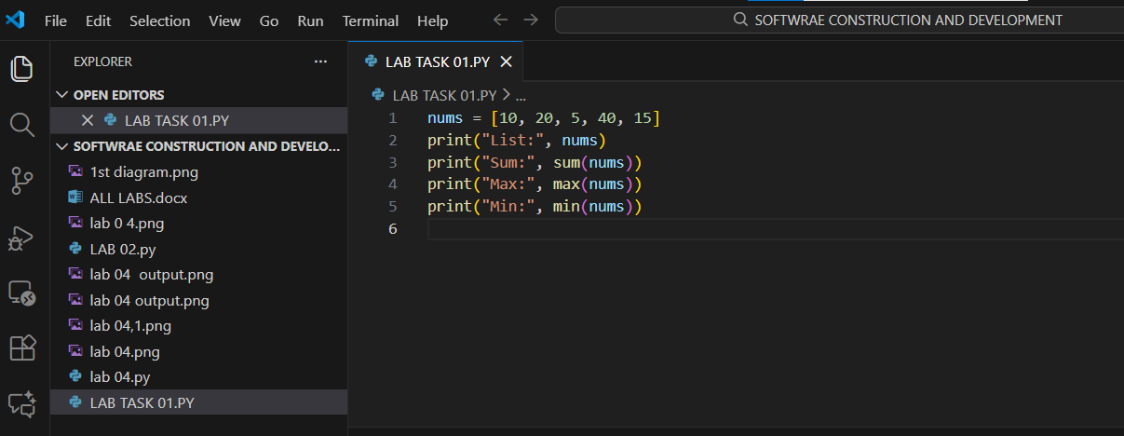

Output:
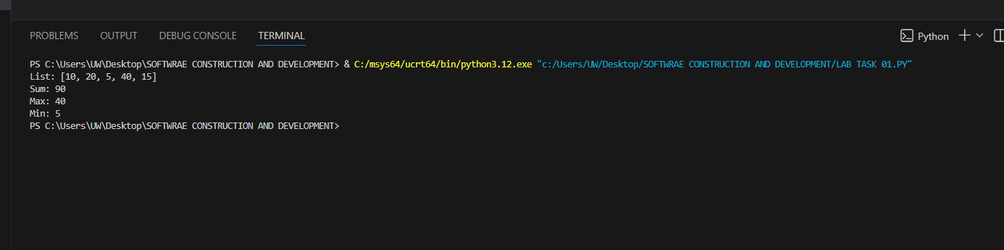

Code no: 07

Store 5 Names in List:
names = []
for i in range(5):
name = input(f"Enter name {i+1}: ")
names.append(name)
print("Names:", names)

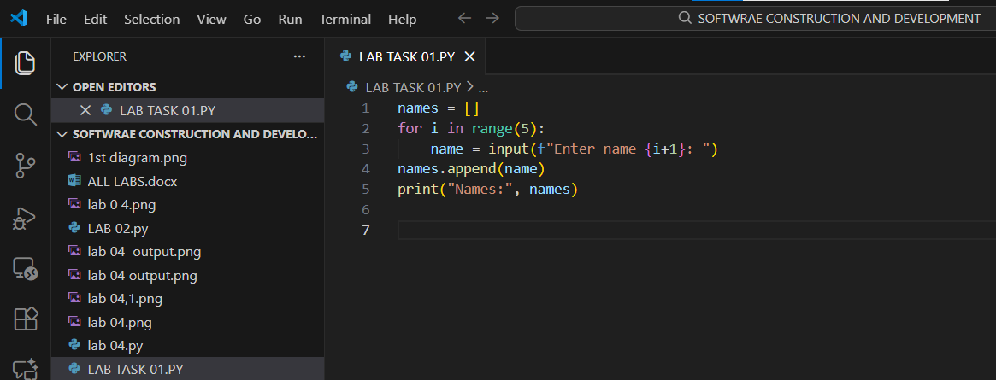

Output:
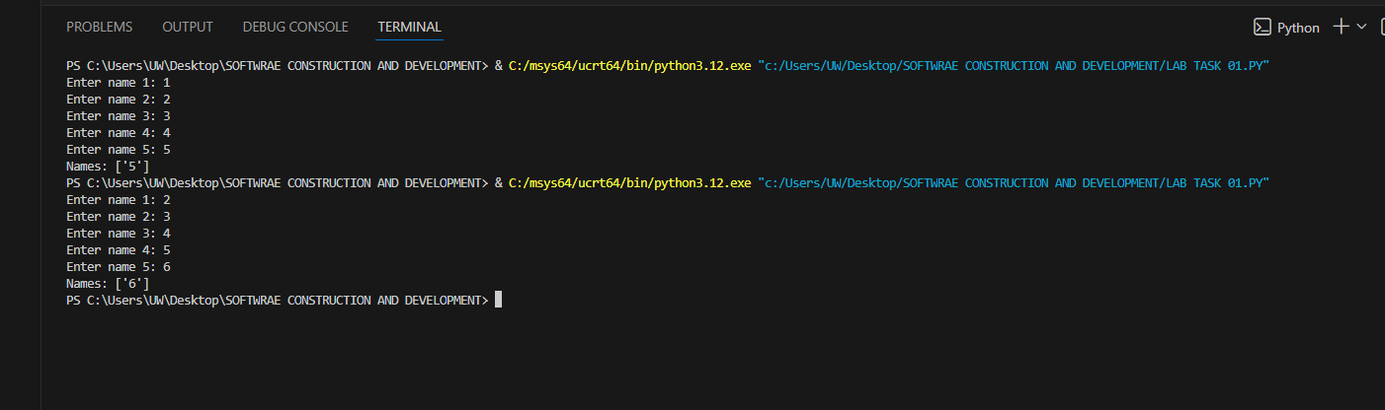

Code no:08

Add Element to End of List:
fruits = ["apple", "banana"]
fruits.append("orange")
print("Updated list:", fruits)

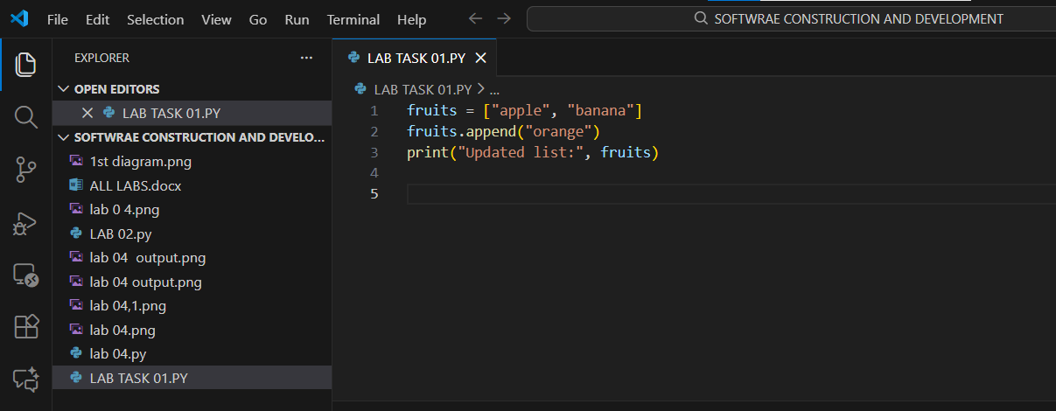

Output:
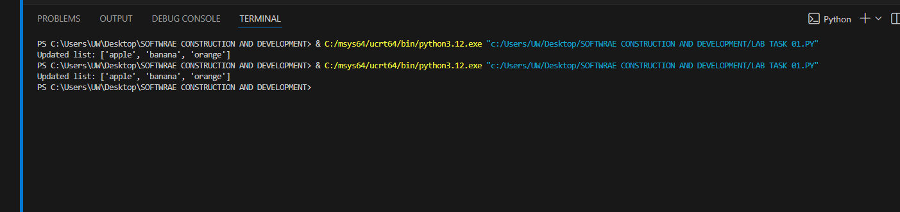

Code no:09

Insert Element at Specific Index:
numbers = [1, 2, 3, 5]
numbers.insert(3, 4) # insert 4 at index 3
print("List after insert:", numbers)

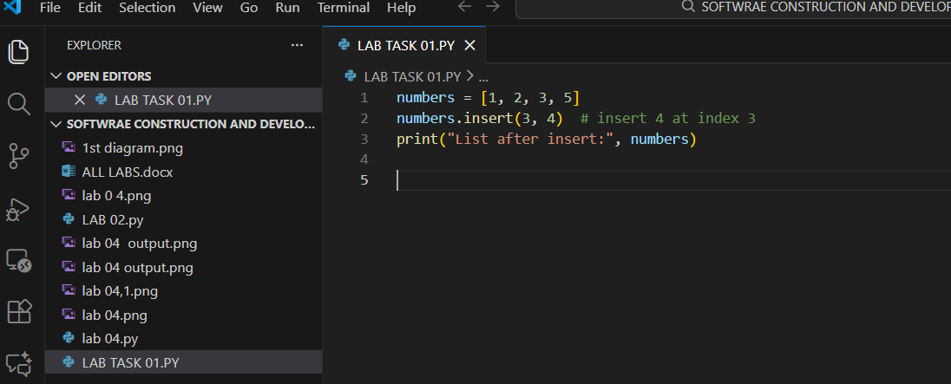

Output:
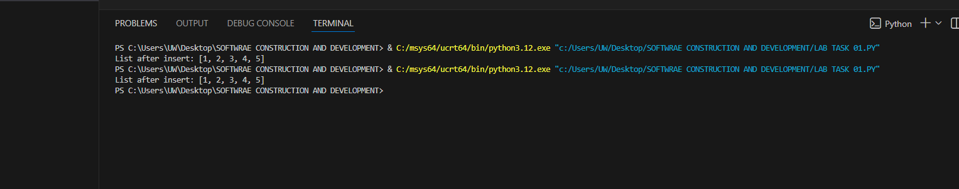

Code no:10

Remove Element using `remove()` and `pop():
items = [10, 20, 30, 40, 50]
items.remove(30) # removes value 30
items.pop(2) # removes item at index 2
print("Updated list:", items)

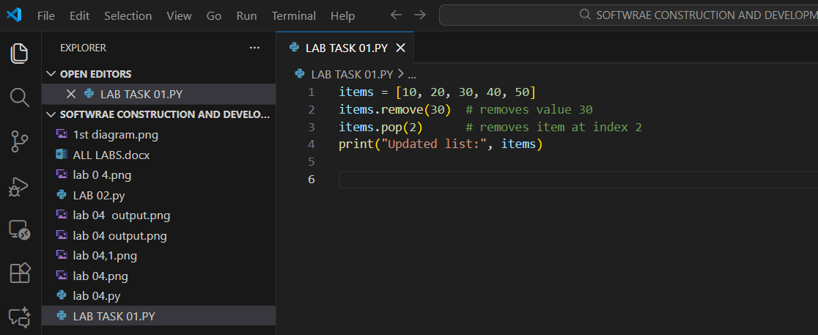

Output:
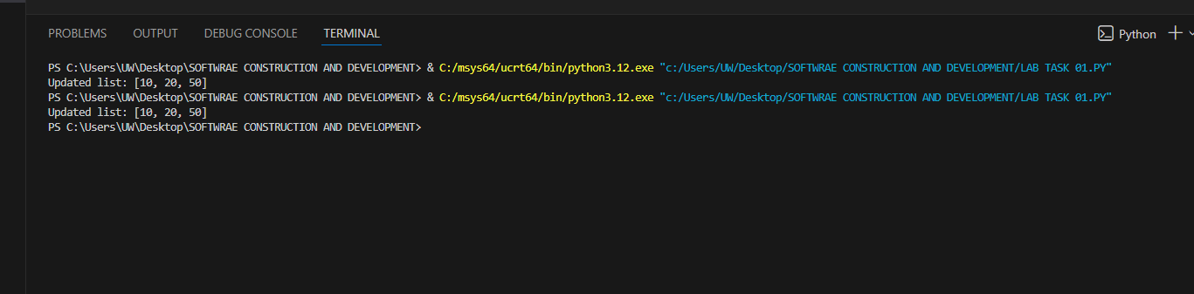

END

